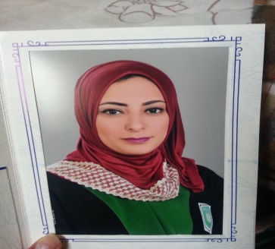Waad mohammed Idrees

ADDRESS:

flat479, road 53, block 557, al-budaya.

**Personal details**

Date of Birth: 20/aug/1992

Marital Status: Single

Nationality: Bahraini

CPR: 920805671

E-Mail address: wa.92.3d@gmail.com

Mobile: 37223364/66970017

**Objective**

Accounting graduate looking for a position in Auditing/Accounting where I can utilize my skills, put my learning into practice and make a contribution. I am eager to learn, and excited about beginning my career in this dynamic industry.

Looking forward for a better future

Improve my knowledge in major

**Education**

* Bachelors degree in accounting from Ajlun University

*Graduated in July 2016*

* Saar Secondary School.

**Working experienc**

*Training at Business house Bahrain Co. From 25-december -2017 to 14-june -2018*

**skills**

* Excellent written and verbal communication skills
* Able to learn quickly
* Process entrepreneurial spirit
* Combine patience, determination and persistence to understand & solve problems
* Proven adaptability to differing culture and business environments
* Team work
* excellent knowledge in office program(exel, word,poerpoint,access)
* Training course for the qualification of accountants
* Excellent in Arabic
* driving license
* Good in english